DAY-5(28/5/2025)

Emp ID : 110714877

NAME :Kinnera venkatamma

Task1 . Create a Directory with the Name Linux Practice.

mkdir directory_name – This creates a directory in the current working directory

mkdir (make directory)

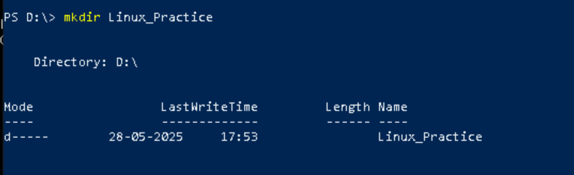

Task2. Change to the directory

cd directory name -this moves you into the specified directory

cd ..(go up one directory)

cd ../.. (go up two directories)

cd ~(go to your home directory)

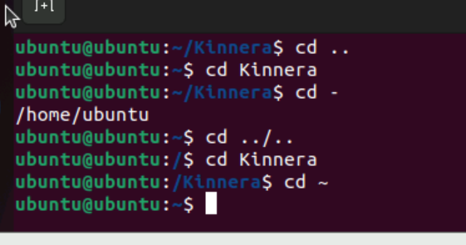

Task3 . Create a file names TestFile1.txt and add the content to it.

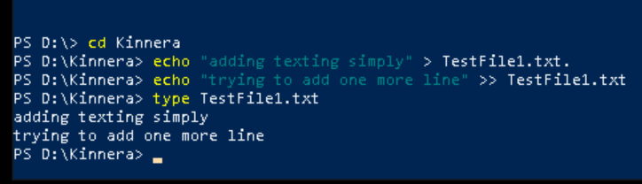

Task4 . Create a Folder named Dummy and try to delete it.

rm folder_name – delete/remove folder

rm -r directory_name -delete directory

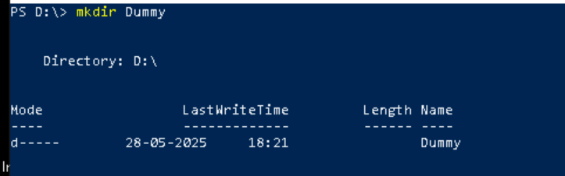

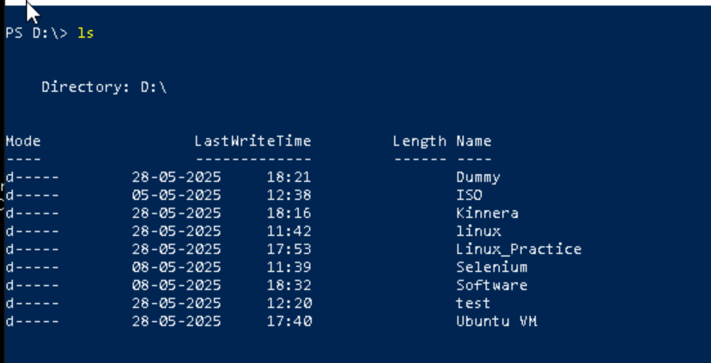

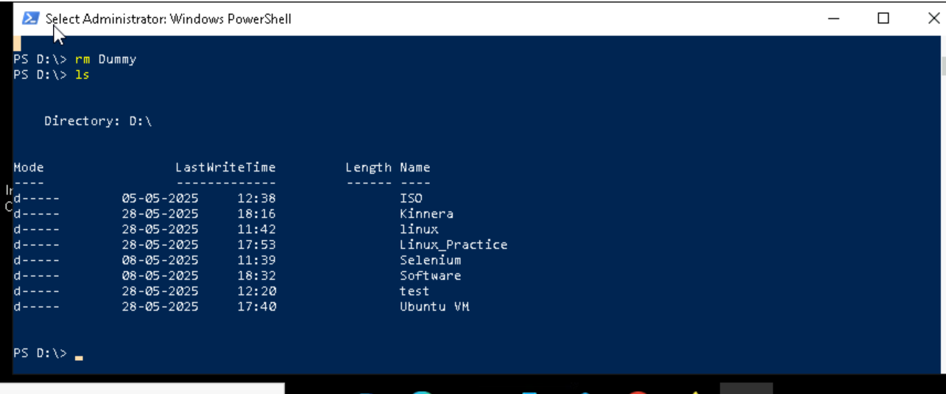.

Task5 . Plz check the working directory

pwd -to check current working directory

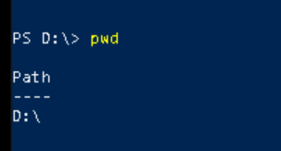

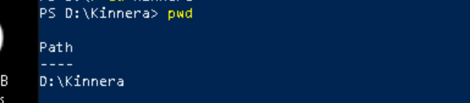

Tsk6 . How do you check all the files and directories in the directory you are in?

ls – used to list the files/directories in a directory

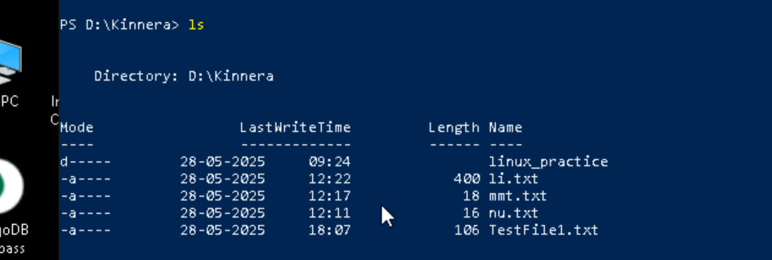

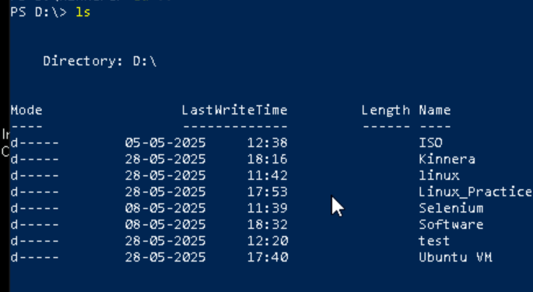

Task7. Create five files named TestFile2.txt.. TestFile3.txt… and so on till TestFile6.txt

touch -used to create an empty file

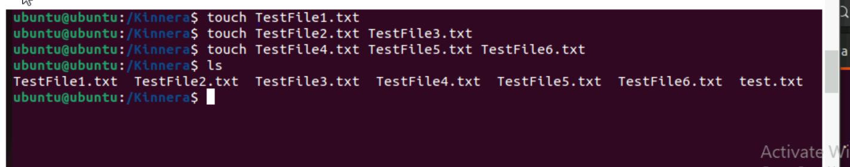

Task8 . Copy all files from Dir 1 ti Dir 2

cp Dir1 Dir2 – copies files from source to destination

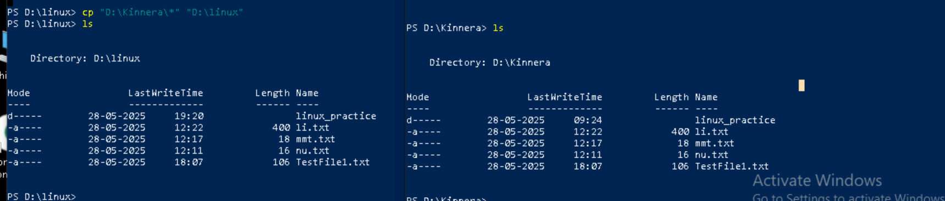

Task9. Move all files from Dir 2 to Dir 3 (finally ur Dir 2 should be empty)

mv Dir2 Dir3

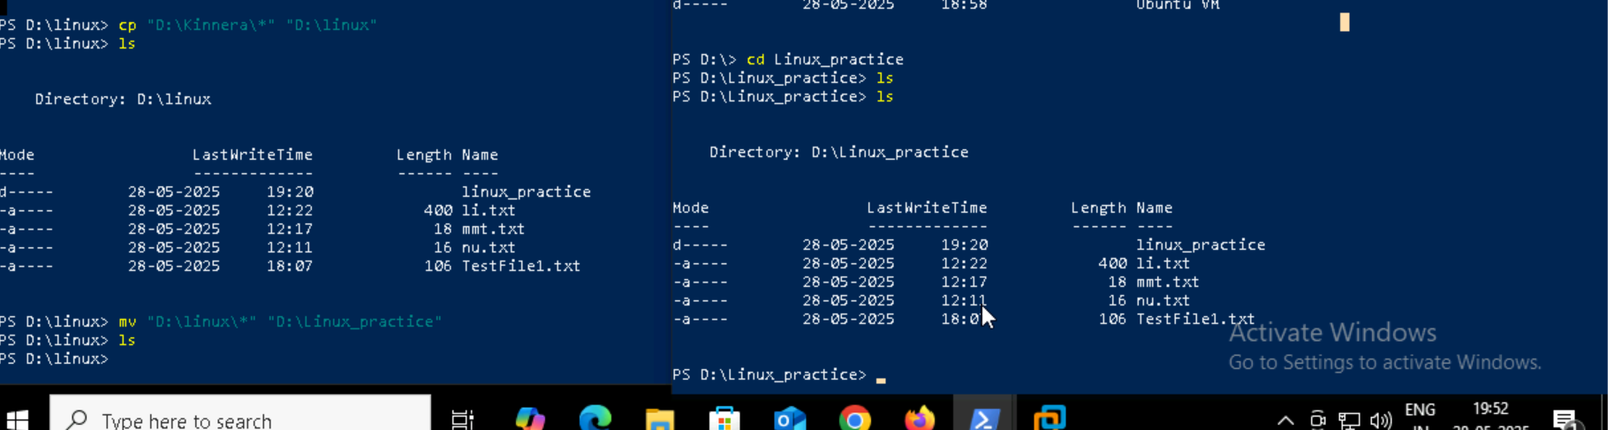

Task 10 . Can you plz show me the diff between **rm** and **rmdir** commands with screen shots ?

rm -used to delete files

rmdir -used to remove/delete directory

Files Before using rm

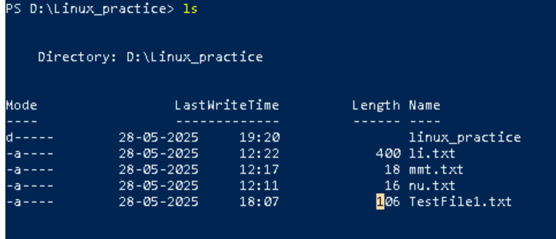

After using : rm file removed/deleted

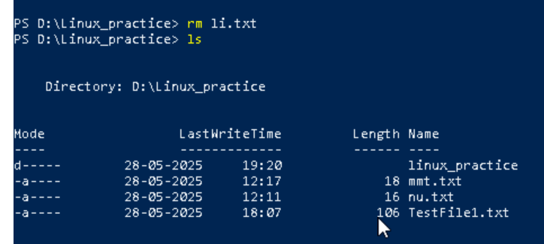

Before using rmdir

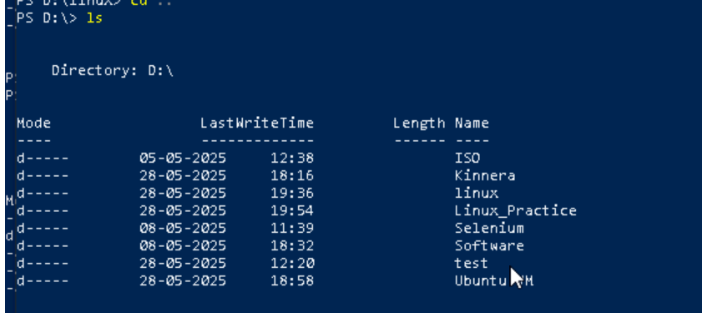

After using rmdir : directory deleted/removed

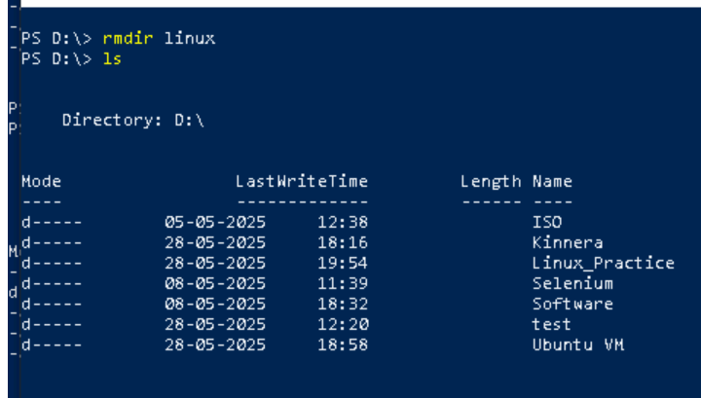

Task 11. Now use specifically use cat command to create a file

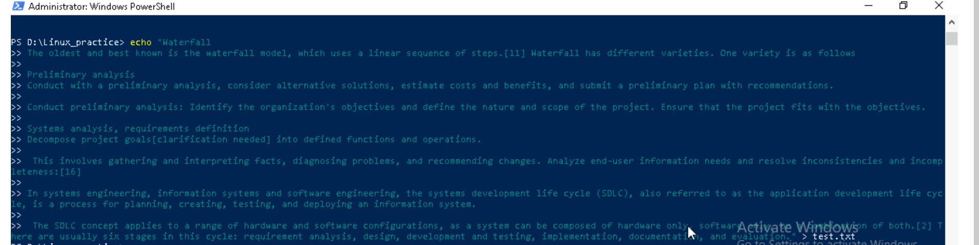

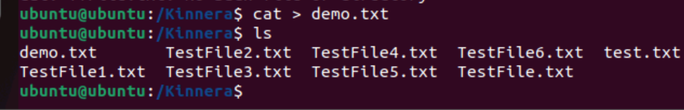

Task 12. How to get only the top part of your file..



Task 13. How to get only the last part of your file



Task 14. Plz add dummy text of 5 to 6 pages in to the same file

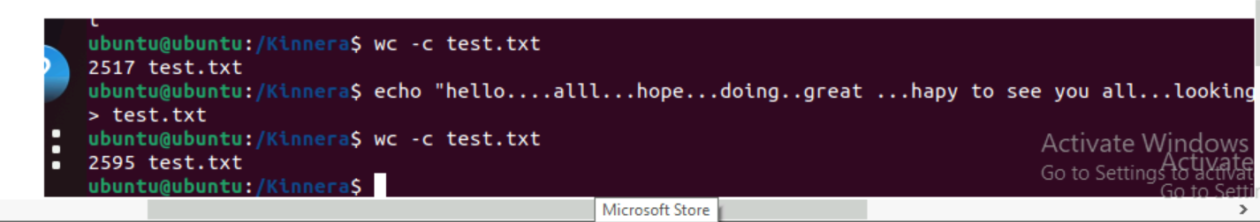here if we add multiple paragraphs unable to take ss in ubuntu hence used small line & shown word count (as added some text to same file)

Task15. Use more command on the above file and find out the diff between less command and more command.

When we run: more test.txt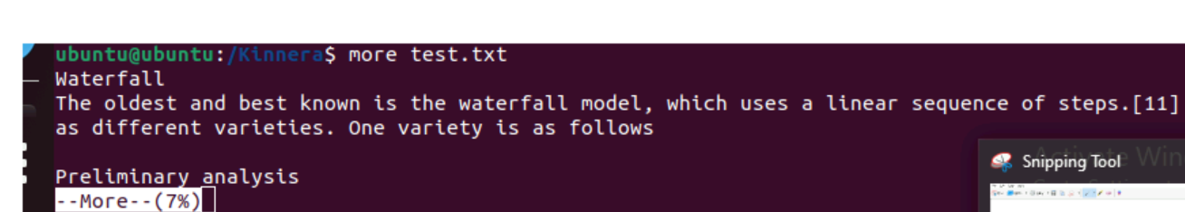

When we run : less test.txt

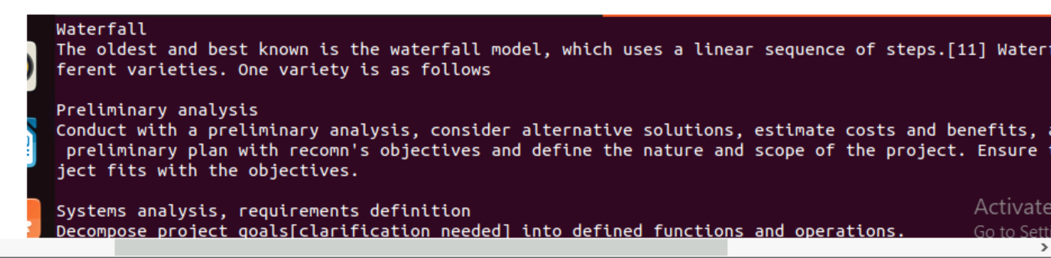

Task 16 . Can you use echo command with -e and see the diff.. Also take a ss and paste .

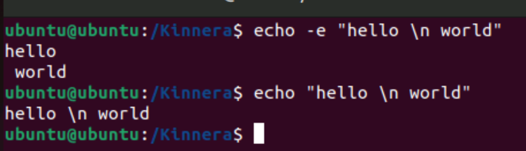

Task 17. What is diff between ls and ls -l command .. ss plz

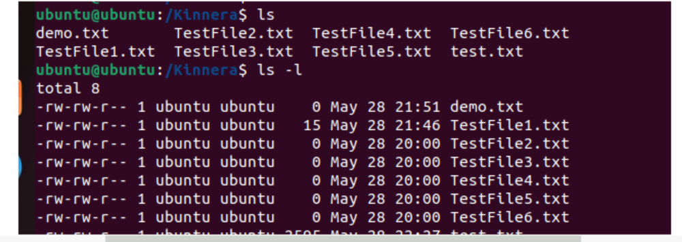

Task 18. Create  a file using **touch** command , **cat** command and **echo** command and take ss (screen shot)..

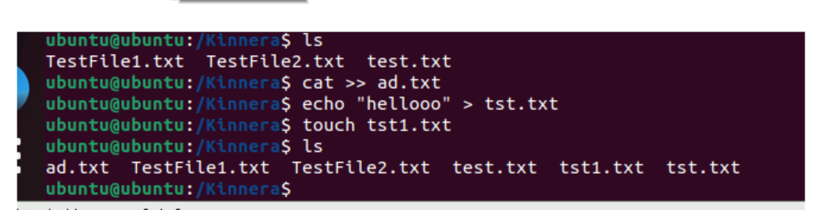

The echo, touch, and cat commands in Linux serve distinct purposes:

echo: displays text or variable values,

touch :creates or updates files (primarily for timestamps), and

cat :concatenates and displays the contents of files.

Task19 . Can you guys try to display the calendar by using a command..

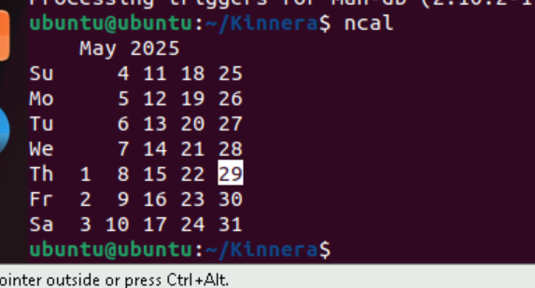

Task 20. Can you go back to 1 directory .. at a time  whats the command

cd ..

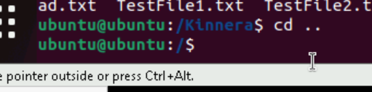

Task 21. How to know whose user u are working on ?

whoami - Is used to show the current user you’re logged in as

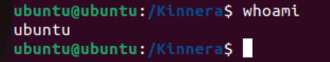

Task 22. Try to find out who is peeping into your system..

who & w

who -shows who is logged in to the system

w- shows who is logged in & what they are doing

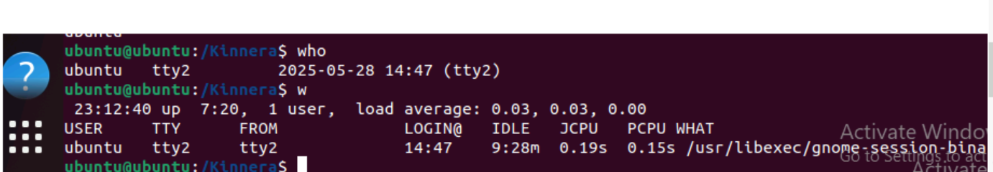

Task 23. Can you guys try to check how much disk space is consumed..

df -h -shows disk space usage in a human readable format

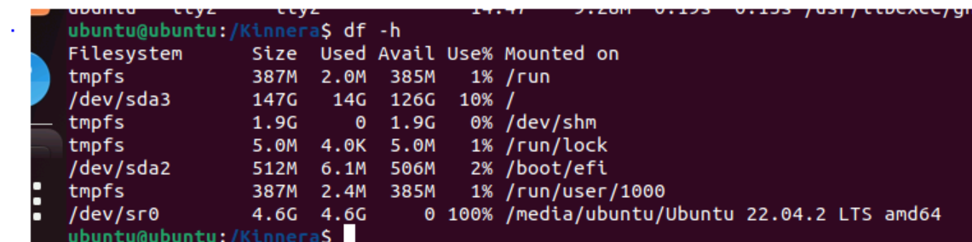

Task 24. Can you plz try using the below commands

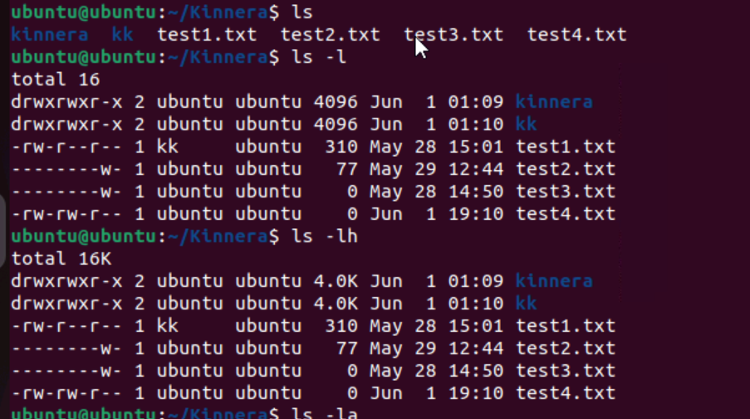

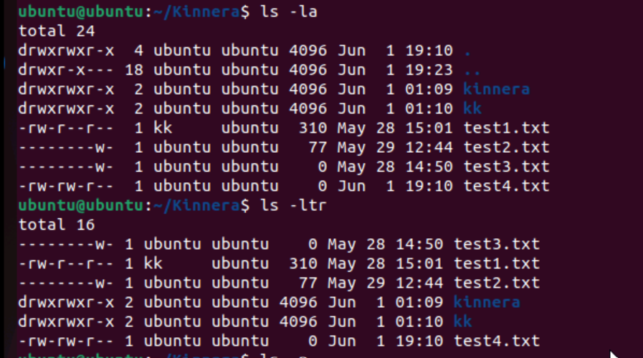

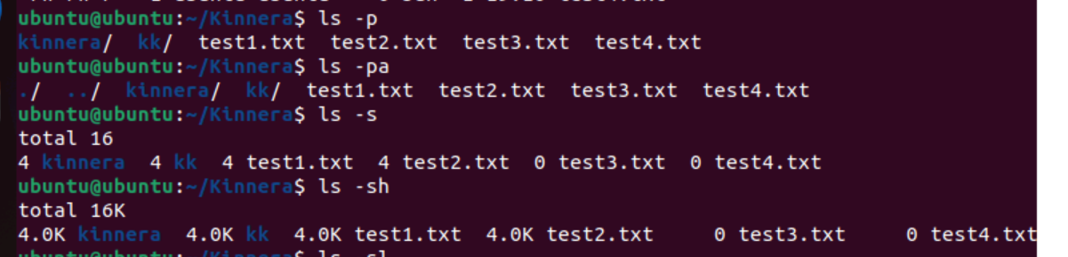

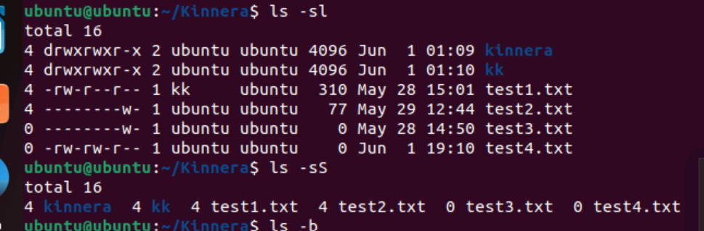

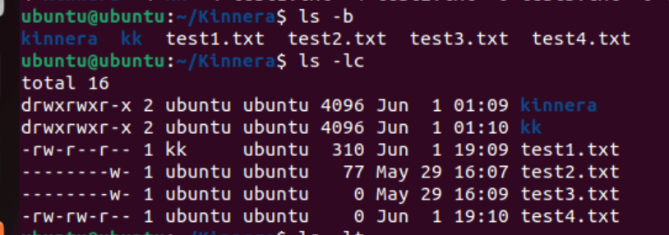

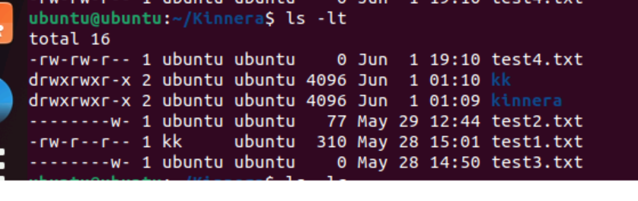

Task 25. Find the list pf all files ending with .txt

ls *.txt



Task 26. In Linux all the hidden files starts with . (period) & How to check all the hidden files in Linux..

ls -a



Task 27. What is the difference between . and .. in linux ?give Line 1 line for each

In Linux, the dot (.) and double dot (..) are used for path navigation in the command line.

The dot refers to the current directory,

while the double dot refers to the parent directory.

Task 28. Can you create a file using vi editor and show the details in ss

Hint:

 Esc is for come out of the edit mode

Press two keys Shift &plus; ZZ together to come out of the file completely

* I - to insert

To move inside the file

* **l** key to move to the right side.
* **h** key to move to the left side.
* **k** key to move upside in the file.
* **j** key to move downside in the file.

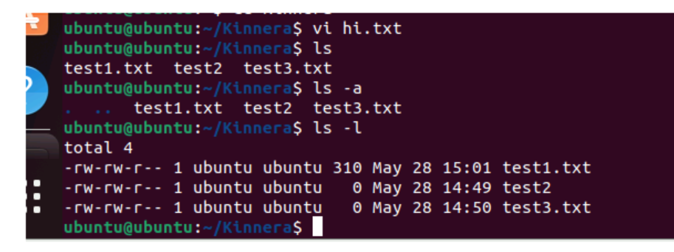

Task 29. How to find the no of words in the file

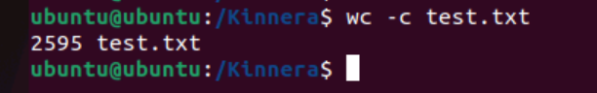

Task 30. What is the use of cat -b myfilename.txt command?

It’s giving numbering to lines

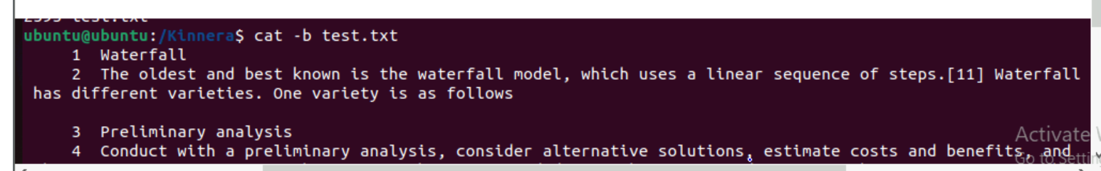

Task 31. Can I use the wc with 2 or more files?

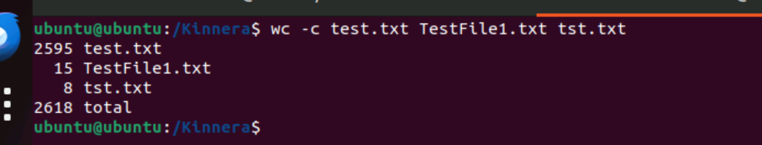

Task 32. How to copy content of one file to another file

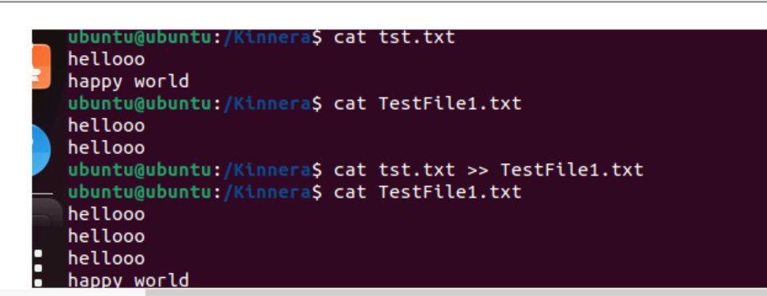

Task 33. Now I want to rename my file with MYFILENEW can i do that if so how ?

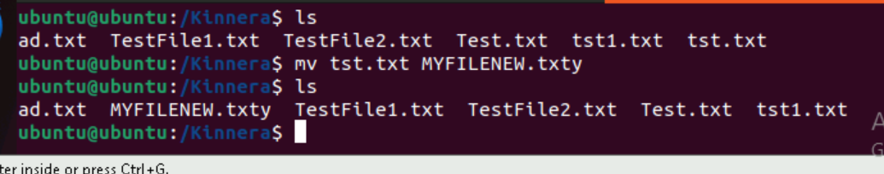

Task 34. Can i remove or delete multiple files in linux..? How?

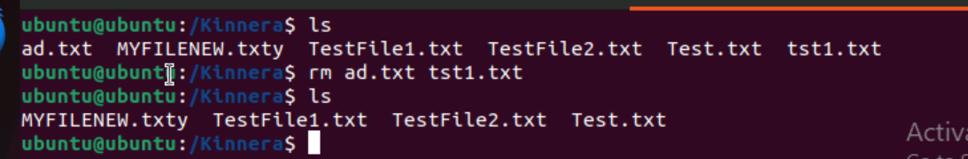

Task 35. In directory / slash is root  …  can you try cd / what is it doing?

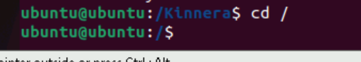

Task 36. What is the way go go to home directory ?



Task 37. If i want to move to different users home directory

cd ~username

ex: cd ~Kinnera

